

**Tribhuvan University**

**Faculties of Humanities and Social Sciences**

**Gym Subscription Management System**

**A PROJECT REPORT**

**Submitted to**

**Department of Computer Application**

**Danfe College**

**Sinamangal, Kathmandu**

**In partial fulfillment of the requirements for the Bachelors in Computer Application**

**Submitted by**

**Suman Mushyakhwo (6-2-920-32-2020)**

**Sharmila Pyatha (6-2-920-27-2020)**

**April 12, 2023**

**Under the Supervision of**

**Bijay Mishra**

**TRIBHUVAN UNIVERSITY**

**SUPERVISOR’S RECOMMENDATION**

Thereby recommend that this project prepared under my supervision by Sharmila Pyatha and Suman Mushyakhwo entitled “Gym Subscription Management System” in partial fulfillment of the requirements for the degree of Bachelor of Computer Application is recommended for the final evaluation.

---------------------------------------------

**Mr. Bijaya Mishra**

**Project Supervisor**

**BCA Department**

**Danfe College, Sinamangal, Kathmandu**

**Tribhuvan University**

**Faculty of Humanities and Social Sciences**

**Danfe College**

**Sinamangal, Kathmandu**

**LETTER OF APPROVAL**

This is to certify that this project prepared by Sharmila Pyatha and Suman Mushyakhwo entitled “Gym Subscription Management System” in partial fulfillment of the requirements for the degree of Bachelor in Computer Application has been evaluated. In our opinion it is satisfactory in the scope and quality as a project for the required degree.

|  |  |
| --- | --- |
| ………………………………  Mr. Bijya Mishra  Supervisor  BCA Department  Danfe College, Sinamangal  Kathmandu | ……………………………..  Mr. Bijya Mishra  Program Coordinator  BCA Department  Danfe College, Sinamangal  Kathmandu |
| …………………………………..  Internal Examiner | …………………………………  External Examiner |

**ABSTRACT**

The Gym Subscription Management system is a web-based application that allows gym members to manage their subscriptions. The system provides users with the ability to sign up for gym memberships, view membership options and pricing. The system has two types of users: gym members and gym administrators. Gym members can sign up for memberships, view their membership details. Gym administrators can manage gym membership data, information regarding their exercise. The system uses CRUD operations to manage gym membership data. Users can create new membership records, update membership information, and delete memberships if necessary. The Gym Subscription system is designed to be user-friendly and easy to use. It provides users with a streamlined process for managing their gym memberships and attendance, making it a valuable tool for both gym members and administrators.

**ACKNOWLEDGEMENT**

Apart from the efforts, I would like to thank Mr. Bijay Misra, our project coordinator and lecturer, for his patience, support and open-mindedness. Without his encouragement and guidance this project would not have materialized. We feel motivated and encouraged every time we attend his meeting. We take this opportunity to express our gratitude to the people who have been instrumental in the successful Completion of this project. The guidance and support received from all the members who contributed and who are contributing to this project, was vital for the success of the project.

**Contents**

List of Abbreviations vii

List of tables viii

List of figures ix

Chapter 1: Introduction 1

1.1. Introduction 1

1.2. Problem statement 1

1.3. Objective 2

1.4. Scope and Limitation 2

1.5. Report Organization 2

Chapter 2: Background Study and Literature Review 3

2.1. Background Study 3

2.2. Literature Review 3

Chapter 3: System Analysis and Design 4

3.1. System Analysis 4

3.1.1. Requirement Analysis 4

Non Functional Requirements 5

3.1.2. Feasibility Analysis 6

3.1.3. Data Modeling(ER-Diagram) 7

3.1.4 Process Modeling 8

Context Level Diagram 8

DFD Level 1 9

3.2.1. Architectural Design 10

3.2.2. Database Schema Design 11

3.2.3. Interface Design (UI Interface / Interface Structure Diagram) 12

3.2.4. Physical DFD 14

Chapter 4: Implementation and Testing 15

4.1. Implementation 15

4.1.1. Tools Used (CASE tool, Programming Languages, Data Platforms) 15

4.1.2. Implementation Details of Modules (Description of Procedures / functions) 16

4.2. Testing 18

4.2.1. Test Cases for Unit Testing 18

4.2.2. Test Case for System Testing 23

Chapter 5: Conclusion and Future Recommendations 25

5.1. Lesson Learnt / Outcome 25

5.2. Concussion 26

5.3. Future Recommendations 26

References 27

APPENDICITIS 28

## List of Abbreviations

**DFD** – Data Flow Diagram

**GSMS-** Gym Subscription Management System

**ER** – Entity Relationship

**FR**– Functional Requirement

**HTM**L–Hypertext Markup Language

**PHP** – Hypertext Preprocessor.

**UC** – Use Case

**UI** – User Interface

## List of tables

**Table 1 Test Case 0001 Sign Up** 19

**Table 2 Test Case 002 Sing Up Unsuccessful** 19

**Table 3 Test Case 003 Login** 21

**Table 4 Test Case 005 Add Category** 22

**Table 5 Test Case 006 System Test** 23

## List of figures

**Fig 3. 1 Use Case Diagram** 5

**Fig 3. 2 Gantt chart** 6

**Fig 3. 3 ER Diagram** 7

**Fig 3. 4 Context Level Diagram** 8

**Fig 3. 5 DFD Level 1** 9

**Fig 3. 6 Architecture Design** 10

**Fig 3. 7 Database Schema Design** 11

**Fig 3. 8 Login Page UI** 12

**Fig 3. 9 Signup Page UI** 12

**Fig 3. 10 Dashboard Page UI** 13

**Fig 3. 11 Physical DFD** 14

# 

# Chapter 1: Introduction

## 1.1. Introduction

A web-based Gym subscription system is a digital platform that offers individuals access to Gym-related activities, services, and resources through a subscription model. It allows users to conveniently access Gym options through a website.

With a web-based Gym subscription system, users can access a variety of Gym resources, such as workout routine plans and track membership expiry all through their web browser. These platforms may offer a range of Gym options to cater to different preferences. Users can choose and customize their Gym routine based on their body structure.

## 1.2. Problem statement

After analyzing many existing Gym subscription systems and interviewing several Gym owners, we now have the obvious vision of the project to be developed. Before we start to build the application, we may have many challenges. We define our problem statement as:

The problem statement for a Gym subscription management system in Nepal is that there is a lack of efficient and modern systems for managing Gym subscriptions, which leads to several issues such as lack of proper planning and control, inefficient management of member data, difficulty in tracking payments and subscriptions, and poor communication between gym owners and their members. Most of the Gym centers use Excel and traditional paper-based systems to track the payment, subscription and member data which is a very bad experience in Nepal. This is a significant problem, especially for Gym centers and gyms that are looking to improve their services and attract more members. The traditional paper-based system is time-consuming, prone to errors, and does not offer the flexibility and convenience that modern-day member’s demand. And excel is very difficult to set formulas according to their needs. Therefore, there is a need for a digital solution that can help Gym centers and gyms manage their subscriptions effectively, automate payments and reminders, and improve overall member experience.

## 

## 

## 

## 1.3. Objective

Some objective of Gym Subscription Management System are as follow:

* To reduce the time and effort in maintaining records
* To reduce redundancy in records.
* To make it easy to keep and search records of many people.
* To track the membership expiry date and ask for renewing their membership.
* To provide a proper exercise routine according to their body structure.
* To track payments info.

## 1.4. Scope and Limitation

**1.4.1 Scope of System**

* Members can request for routine and view their routine through website
* Admin can manage data of members, categories and routines.
* Admin can keep track members subscription expiry date.
* Every Gym center can use this system to maintain data and other facilities.

**1.4.2 Limitation of Existing System**

The limitations of a Gym management system can depend on its specific design, implementation, and features. Here are some common limitations that may be associated with Gym management systems in the context of Nepal:

* Many gyms use Excel to keep track of their data, but this isn't the best way to do it.
* User interface is poorly designed.

## 1.5. Report Organization

**Chapter 1** includes introduction of the system Gym Subscription Management System with its problem of statement, objective and its scope and limitation.

**Chapter 2** includes the background study of Gym Subscription Management System and some literature review of other Gym Subscription Management System systems.

**Chapter 3** includes the functional and non-functional requirements along with feasibility

Analysis and architectural design of the Gym Subscription Management System.

**Chapter 4** includes the tools used in this system and the testing that is done.

**Chapter 5 i**ncludes about the outcome of this system as well as the future recommendations for the Gym Subscription Management System.

# Chapter 2: Background Study and Literature Review

## 2.1. Background Study

A Gym Subscription Management System is a software application or platform designed to assist individuals and organizations in managing various aspects of Gym and wellness. It provides tools and features that help with tracking, monitoring, and improving physical activity, and membership expiry date. Understanding the Gym industry, its trends, and the challenges faced by Gym professionals and enthusiasts is crucial. Explore topics such as gym management. Given the sensitive nature of personal health and Gym data, it is important to consider security and privacy concerns when designing or using Gym management systems. Study topics such as data encryption, secure authentication, and compliance with data protection regulations. Analyze existing Gym management systems, both commercial and research-based. Examine case studies, academic papers, and industry reports to gain insights into successful implementations, user feedback, and areas of improvement.

## 2.2. Literature Review

Gym management systems play a crucial role in facilitating the efficient operation and administration of Gym centers. These systems integrate various functionalities, such as membership management, providing routine to members, subscription tracking. This literature review aims to explore the existing research and literature surrounding Gym management systems, highlighting their benefits, challenges, and potential areas for improvement.

Gym management systems enable members to easily register, view workouts plans and track subscription expiry resulting in a more engaging and convenient Gym journey. These systems automate tasks like membership enrollment, and routine scheduling, reducing administrative burdens and allowing staff to focus on delivering quality services.

# Chapter 3: System Analysis and Design

## 3.1. System Analysis

The system analysis of the system is done by conducting requirement analysis, feasibility analysis, data modeling, and process modeling as follows:

## 3.1.1. Requirement Analysis

Functional Requirement

A Functional Requirement is an outline of the service that the Gym Subscription Management System must offer. Features the system must provide are refined into use case diagrams. To best capture the functional requirements of the system.

**Use Case**

The figure 3.1 is the use case diagram of the Gym Subscription Management System. There are three actors Member, Admin and Trainer.

* The Admin shall be able to search members through name.
* The member shall be able to view the exercise routine.
* An Admin shall be able to login through their email and password
* A member shall be able to login through their email and password.
* A member shall be able to logout.
* A member shall be able to choose subscription categories.
* A member shall be able to request routine from the admin.
* An admin shall be able to manage categories, routine and member database.
* A member shall be able to see payment records from the beginning of his own.
* An admin shall be able to retrieve payment records of all members.
* A member shall be able to view their subscription expiry date.
* An admin shall be able to update members’ subscription date.
* An admin and members shall be able to update their profile info.

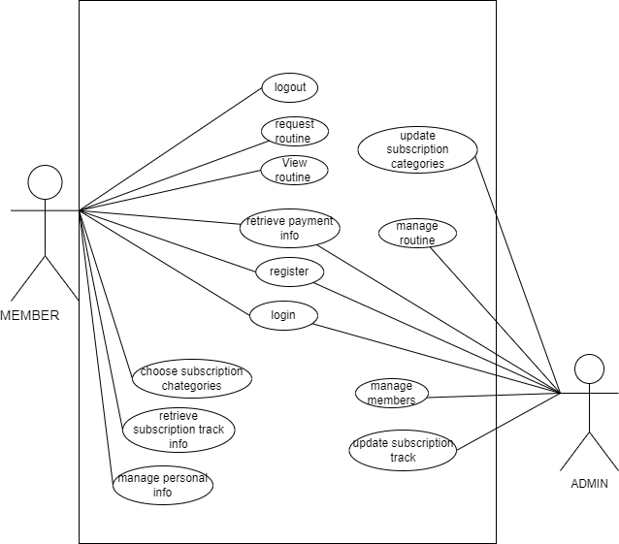

**Fig 3. 1 Use Case Diagram**

## Non Functional Requirements

* **Performance Requirement:** This system is designed for clean overall performance results. The performance of the Gym Subscription Management System will highly depend on the performance of the hardware and software components of the installed devices. Responses to view information shall take no longer than 5 seconds to appear on the screen.
* **Usability Requirement:** This system is very easy to use as it is written using basic html and php so that the user can interact with the system easily to do the needed work. And its security feature makes it very secure and reliable.
* **Availability Requirement:** This project is a web-based application. Meaning any browsers (ME Chrome etc.) can be used. Also, the system shall be operational 24hrs a day and 7 days a week.
* **Environmental Requirement:** The system shall require a localhost server, database server, and a web browser to run successfully.
* **Compatibility Requirement:** The system shall be compatible across all platforms under the required environment.
* **Security Requirement:** Every user shall have a unique Session while logging into the system. The user password shall be in encrypted format in the database

## 3.1.2. Feasibility Analysis

The feasibility analysis of Gym Subscription Management System is done by measuring the following feasibilities, which are explained as follows:

* **Technical** :

The system can be implemented in various technologies presently available and in all technologies that will be implemented in the future.

* **Operational**:

This project is feasible to operate. The current mode of operation provides adequate throughput and response. So this project is entirely operational and can be operated on any platform.

* **Economic**:

No economic feasibility analysis has been conducted, but it can be done based on Function Point Analysis or the Kilo Line of Code method.

**Schedule Feasibility:**

Here is the Gantt chart showing the probability of the project being completed within its scheduled time limits by a planned due date.

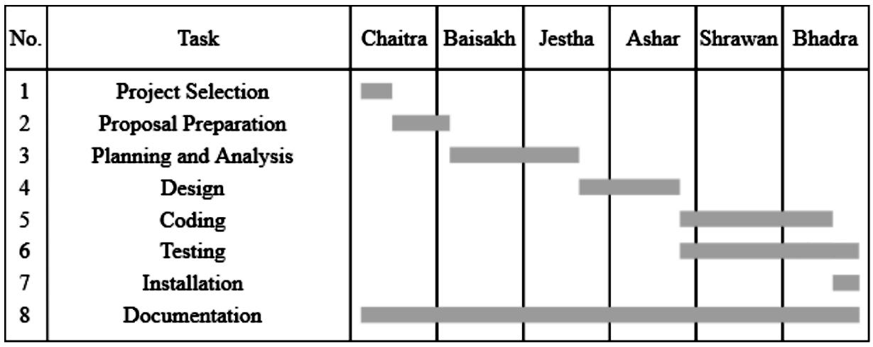

**Fig 3. 2 Gantt chart**

## 3.1.3. Data Modeling(ER-Diagram)

The Entity-Relationship Diagram of our proposed system (Gym Subscription Management System) is given below.

Here, admin manages the data of trainers and members. Each entity has its own primary key attribute. For Example, Members has user member id as a key attribute, and Admin has admin ID as a key attribute.

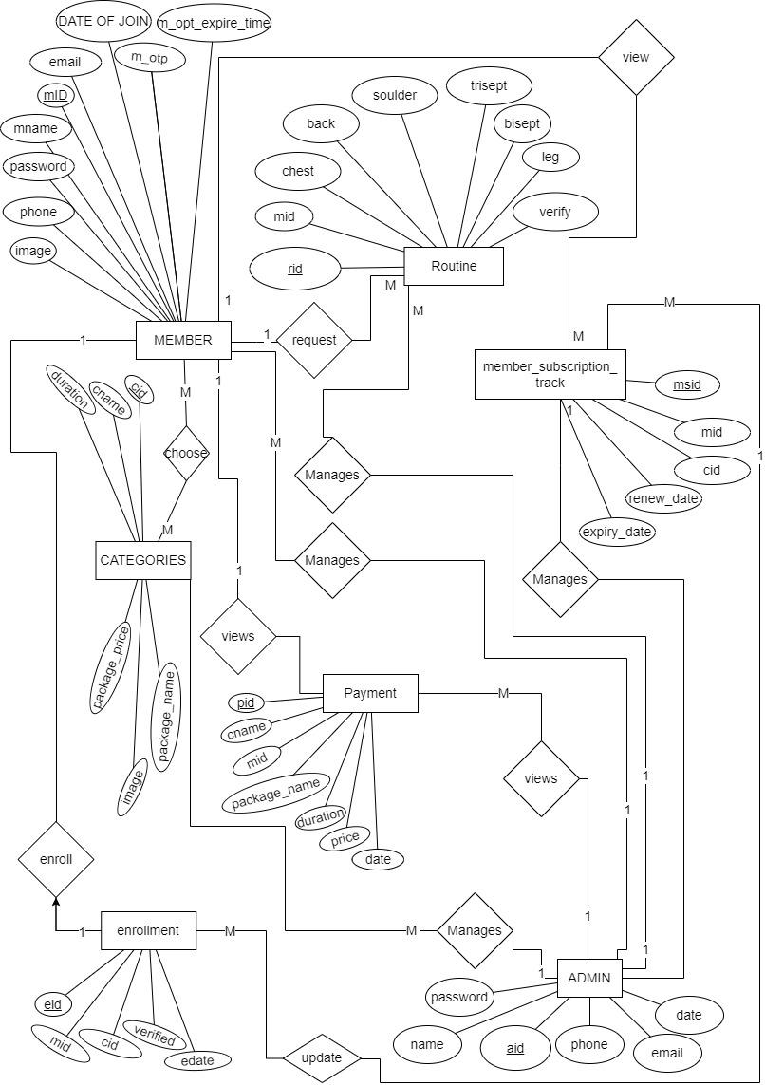

**Fig 3. 3 ER Diagram**

3.1.4 Process Modeling

For process modeling of Gym Subscription Management System, context diagram and DFD level 1 are as follows:

## Context Level Diagram

The context diagram of our proposed system (Gym Subscription Management System) is given below.

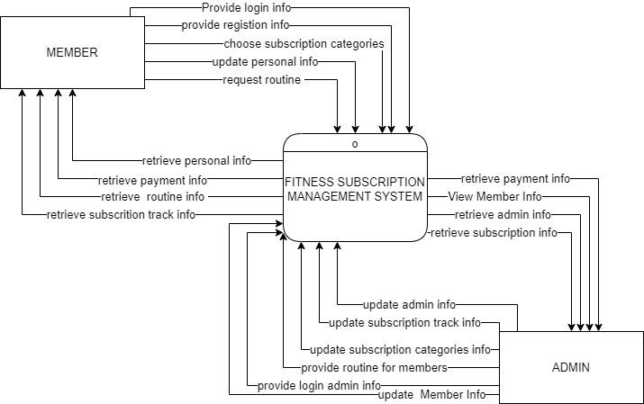

**Fig 3. 4 Context Level Diagram**

## 

## DFD Level 1

The data flow diagram of our proposed system (Gym Subscription Management System) is given below.

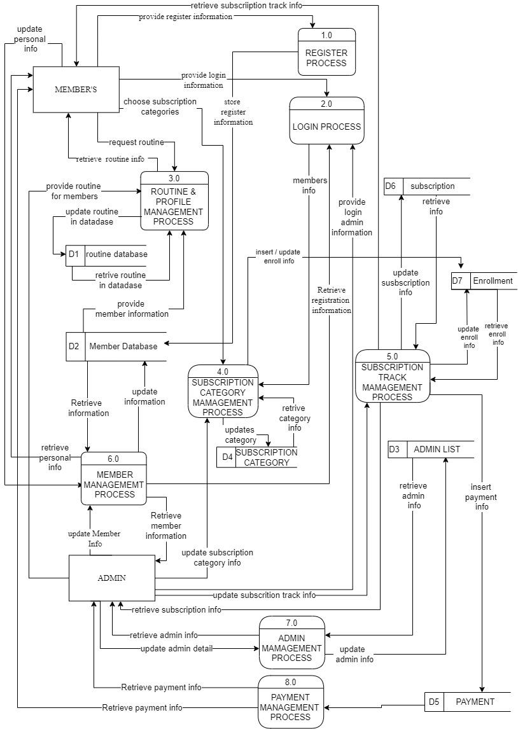

**Fig 3. 5 DFD Level 1**

**3.2. System Design**

The system design of Gym Subscription Management System consists of architectural design, database schema design, user interface design, and physical DFD are shown as follows:

## 3.2.1. Architectural Design

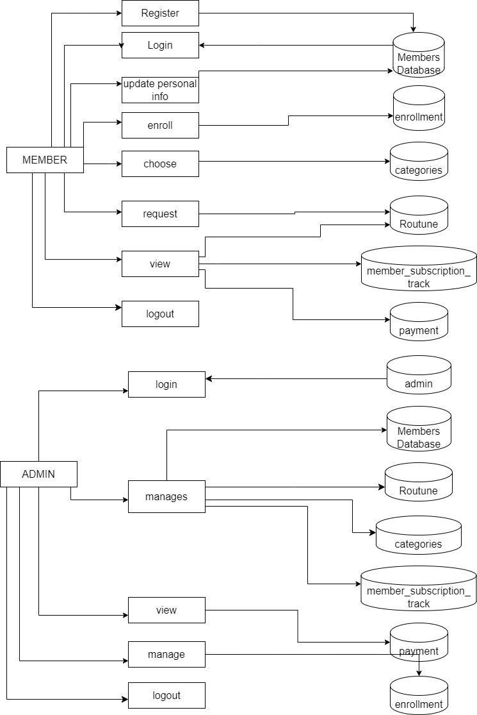

**Fig 3. 6 Architecture Design**

## 3.2.2. Database Schema Design

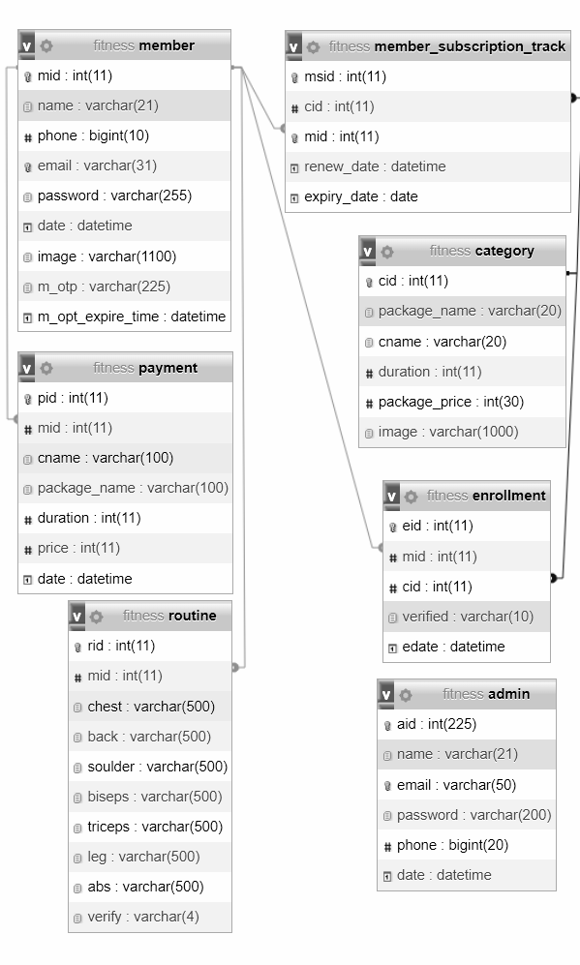

**Fig 3. 7 Database Schema Design**

## 3.2.3. Interface Design (UI Interface / Interface Structure Diagram)

The interface design for all the major pages of GSMS are shown as follow:

**Login Page UI**

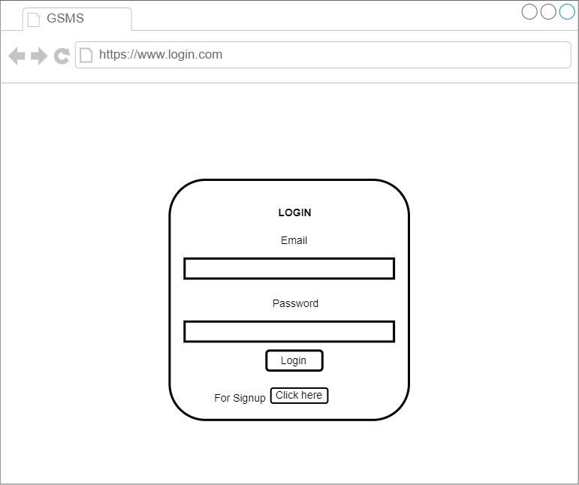

**Fig 3. 8 Login Page UI**

**Signup Page UI**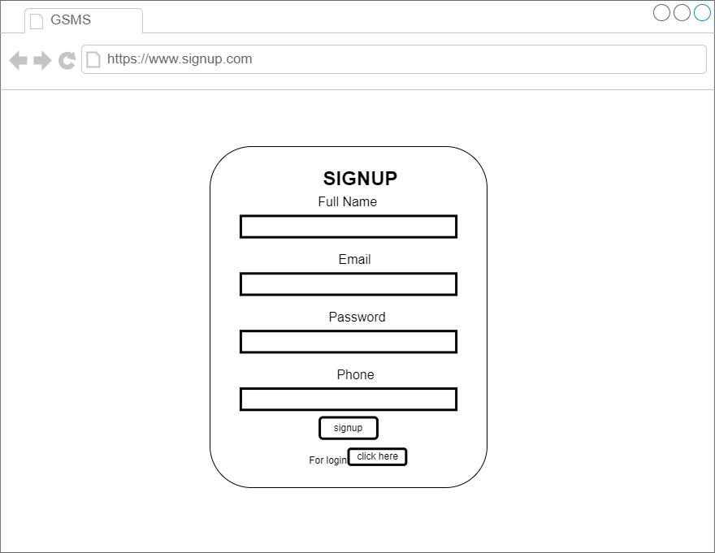

**Fig 3. 9 Signup Page UI**

**Dashboard Page UI**

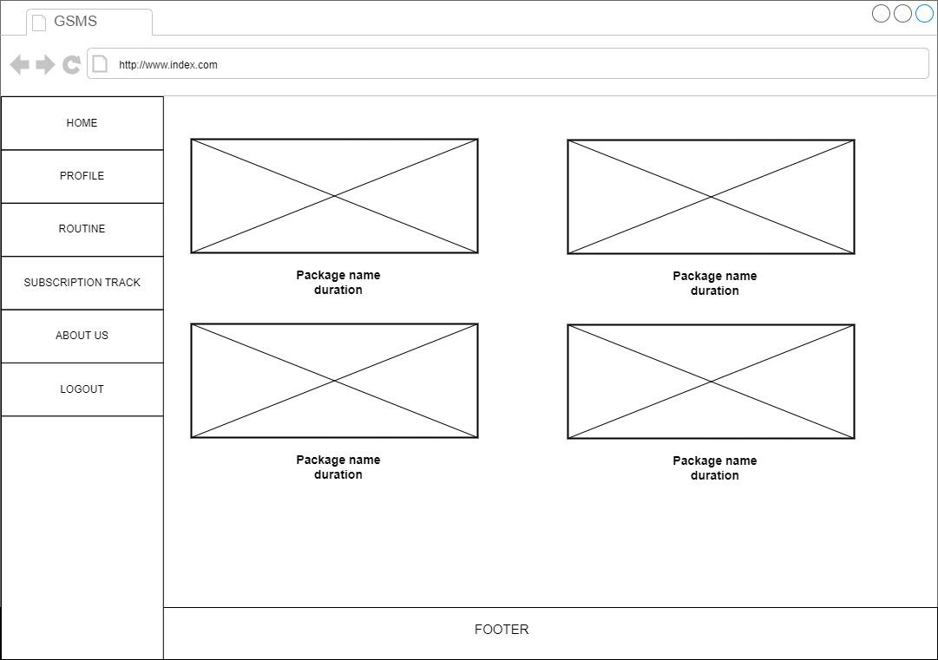

**Fig 3. 10 Dashboard Page UI**

## 3.2.4. Physical DFD

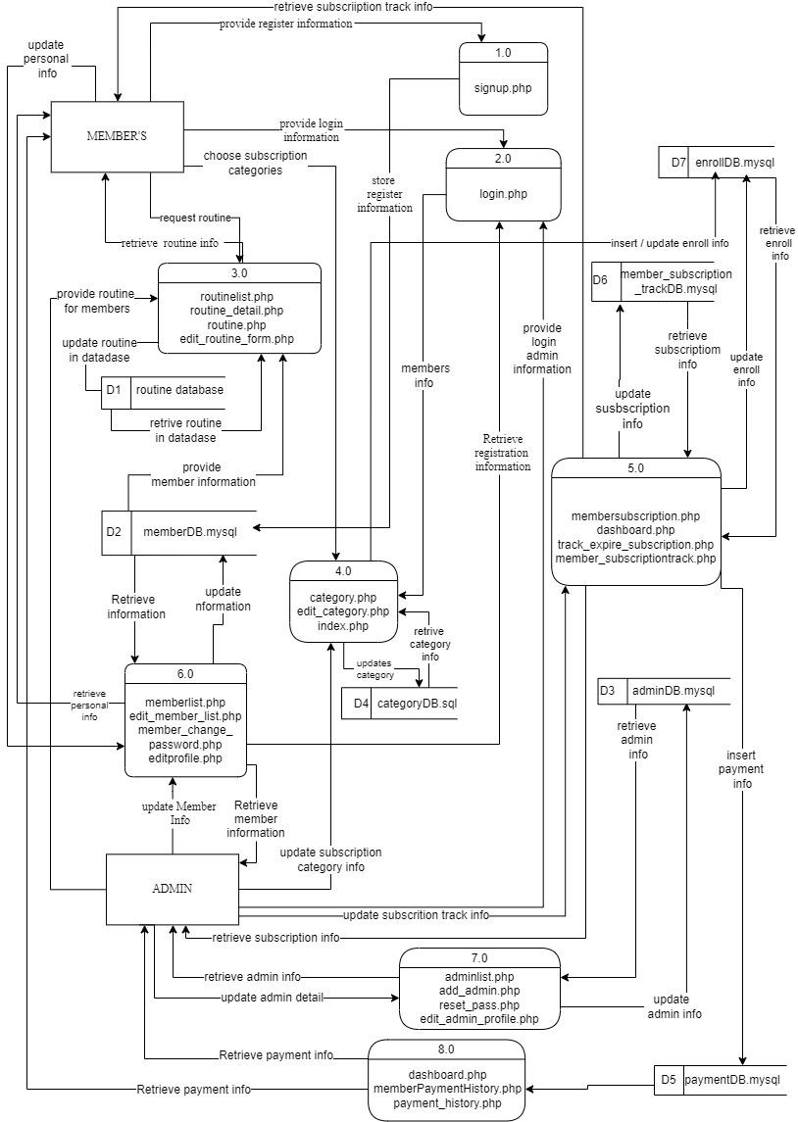

**Fig 3. 11 Physical DFD**

# 

# Chapter 4: Implementation and Testing

## 4.1. Implementation

The tools and techniques used to implement the system and the implementation details of various modules of Gym Subscription Management System are as follows:

## 4.1.1. Tools Used (CASE tool, Programming Languages, Data Platforms)

The tools used for the implementation of Gym Subscription Management are listed below:

**Draw.io**

Draw.io is an online diagram editor constructed around google drive. Using draw.io we have been capable of creating UML diagrams, entity relations diagrams, and plenty more. One of the benefits of draw.io is that it stores the information in google drive, consequently, there's no need for an extra third party.

**HTML CSS & JavaScript**

HTML, CSS, and JavaScript were used for the front-end development. HTML was used for the web page elements. CSS was used to provide its styling to the components. JavaScript was used for client-side validations and adding dynamic components to the Website.

**PHP**

PHP is a server-side scripting language that is embedded in HTML. It is included with some of the famous databases, which include MySQL, and its usage has helped us add, delete, and modify elements inside our database via PHP. Using PHP, we had been capable of limiting customers to get entry to a few pages of our website.

**MySQL**

MySQL is presently the most famous database management system software used for dealing with relational databases. It was used along with PHP scripts for developing our database structure. It became extensively utilized to carry out numerous activities like insertion, deletion, and update of the records saved in the database.

**Visual Studio Code**

Visual Studio Code is a lightweight but powerful source code editor which runs on computer systems and is available for Windows, macOS, and Linux.

## 

## 4.1.2. Implementation Details of Modules (Description of Procedures / functions)

The major function module of Gym Subscription Management System and their implementation is shown in the figure below:

**Signup module**

This module is used to register the new member into the system. Here the member has to fill up all the necessary details about themselves to get registered. These data gathered are first validated and then stored into the database using SQL query. After the registration the registered user shall log into the system by providing email and password which is identical to the email and password stored into the database.

$sql = "INSERT INTO member (name, email, phone, password) VALUES ('$name','$email', '$phone', '$password')";

**Edit Member Detail Module**

This module is used to update the existing member into the system. Here the member has to update all the necessary details. The data gathered are first validated and then updated into a database using SQL query.

If there is image sql will be:

$sql = "UPDATE member SET name='$n', phone='$ph', email='$e', image='$file_name' WHERE mid='$mid'";

If there is no image sql will be:

$sql = "UPDATE member SET name='$n', phone='$ph', email='$e' WHERE mid='$mid'";

**Delete Member Detail Module**

This module is used to delete the data of existing member into the system.

$sql = "DELETE FROM member WHERE mid='$id'";

**View all Members Detail**

This module is used to view the total member details which are existing into the system.

$sql = "select * from member";

**Add Category Module**

This module is used to add the category into the system. Here the Admin has to fill up all necessary details about that category.

$sql = "INSERT INTO category (package_name,cname, duration, package_price, image) VALUES ('$pname','$cname', '$duration', '$price', '$file_name')";

**Edit Category Module**

This module is used to edit the details of categories into the system.

$sql = "UPDATE category SET package_name = '$pname', cname = '$cname', duration = '$duration', package_price = '$price',image = '$file_name' WHERE cid = $cid;";

If image is not uploaded

$sql = "UPDATE category SET package_name = '$pname', cname = '$cname', duration = '$duration', package_price = '$price' WHERE cid = $cid;";

**View all Category Detail**

This module is used to view the total category details which are existing into the system.

$sql = "select * from category";

## 

## 4.2. Testing

The testing section is accomplished to validate the Gym Subscription Management System. The Gym Subscription Management System is examined to test if the final system can work in keeping with what we have been waiting for and is free from any programming and logical errors. It additionally makes sure whether or not all of the systems and requirements are met or not.

## 4.2.1. Test Cases for Unit Testing

Unit testing is a software program development method in which the smallest testable components of an application, known as units, are individually and independently scrutinized for correct operation. Below are the numerous tables for distinctive test cases:

**Table 1 Test Case 0001 Sign Up**

|  |  |  |  |  |
| --- | --- | --- | --- | --- |
| **S.N.** | **Test Case** | **Input** | **Expected Outcome** | **outcome** |
| 1 | Navigate to  sign up page | Path : http://localhost/ project/ signup.php | sign in page should open | As Expected i.e. Member is navigated to sign in page of system |
| 2 | Provide own details | Full name:  Email:  Password:  Confirm Password:  Phone no. | Credential can be entered | As expected |
| 3 | Click on signup button | clicked | User should sign up. | As expected. |
| **Post-conditions: Signup successful** | | | | |

**Table 2 Test Case 002 Sing Up Unsuccessful**

|  |  |  |  |  |
| --- | --- | --- | --- | --- |
| **S.N.** | **Test Case** | **Input** | **Expected Outcome** | **outcome** |
| 1 | Whenever the Name field contains a number or a symbol | Eg:  sum2an mushya@khwo | Display error message. | An Expected Error message is displayed. |
| 2 | If the name contains more than 20 alphabets | Eg:  suasdwawdaman mushyakhwo | Display error message. | As expected,  Error message is displayed. |
| 3 | if the phone number is less than or more than ten numbers long and contains any alphabets | Eg:  9862123456d12 | Display error message. | An Expected Error message is displayed. |
| 4 | if an invalid email address is entered | Eg:  sumahyakhwogmailcom | Display Error message:  Output. | An Expected Error message is displayed. |
| 5 | if the email address entered is already registered |  | Display error message. | An Expected Error message is displayed. |
| 6 | if the password length is less or more than 10 characters | Eg: sumaasdadsn@1234 | Display Error message:  Output. | An Expected Error message is displayed. |
| 7 | if the password and confirmation password do not match |  | Display error message. | An Expected Error message is displayed. |
| **Post-condition :Sign Up Unsuccessful** | | | | |

**Table 3 Test Case 003 Login**

|  |  |  |  |  |
| --- | --- | --- | --- | --- |
| **Pre-conditions : The member has a valid email and password.** | | | | |
| **Dependencies:sign-up module** | | | | |
| **S.N.** | **Test Case** | **Input** | **Expected Outcome** | **outcome** |
| **1** | Navigate to login page |  | Login page should open | As Expected i.e.member is navigated to Login page of system |
| **2** | Correct email and  password | User must login successfully | User logged  into the system | As Expected i.e. User was able  to access the services provided  by the system |
| **3** | Incorrect email but correct password | User must not login | User was not  logged into the  system | User was not able to access the  services provided by the  system |
| **4** | Correct email but  incorrect password | User must not login | User was not  logged into the  system | User was not able to access the  services provided by the  system |
| **Post-conditions: Member is validated with database and successfully login into GSMS**  **The account session details are logged into the database.** | | | | |

**Table 4 Test Case 005 Add Category**

|  |  |  |  |  |
| --- | --- | --- | --- | --- |
| **Pre-conditions: Admin is login into Gym Subscription Management System** | | | | |
| **Dependencies:login module** | | | | |
| **S.N.** | **Test Case** | **Input** | **Expected Outcome** | **Output** |
| **1** | Navigate to category page |  | category page should open | As expected i.e. admin is navigated to category page of system |
| **2** | Click Add Category Button | Button click | Add category Form page should open | As expected i.e. admin is navigated to add category page of system |
| **3** | Provide all required information | Package name=  categoryname= gym(default)  price=  image= | Credential can be entered | As expected if all textboxes are filled and image validation is successful then it is accepted otherwise we will show an error. Error message. |
| **4** | Data insertion | Click on the add  category | Admin should be able to add a category package into the system | As Expected i.e.  Admin can add the question to the system |
| **Post-conditions**  **The category is successfully inserted into the database.** | | | | |

## 4.2.2. Test Case for System Testing

System Testing is a form of software testing that is executed on a complete integrated system to assess the compliance of the system with the corresponding requirements.

**Table 5 Test Case 006 System Test**

|  |  |  |  |  |
| --- | --- | --- | --- | --- |
| **SN** | **Test case** | **Input** | **Expected outcome** | **Output** |
| **1** | Check with admin login | email:admin[@gmail.com](mailto:sumanmushyakhwo@gmail.com)  password:admin@1234 | Successful login | Open dashboard |
| **2** | Check with delete and edit member from admin site | Click delete and edit button | Must be edited or deleted | Edit and delete messages should be displayed successfully. |
| **3** | Check with add categories | If required fields are filled with defined data type  Then click the add category. | Successful entry of new category | Inserted data into the category table. |
| **4** | Check with delete and edit  Subscription categories | Click edit or delete button | Must be edited or deleted | Edit and delete messages should be displayed successfully. |
| **5** | Check with update or ignore requested routine by admin | Click update or ignore button | Must be updated or ignored. | Update message should be displayed successfully. |
| **6** | Check with add admin | If required fields are filled with defined data type | Successful entry of new admin | Inserted data into the admin table. |
| **7** | Check with delete and edit  admin | Click edit or delete button | Must be edited or deleted | Edit and delete messages should be displayed successfully. |
| **8** | Check member enrollment with verified, Reject and Reset then verify by admin | Click verified.  Reject and reset then verify | Must be verified or rejected or Reset the verified | Verified and reset then verified message should be displayed successfully. |
| **9** | Check with logout | Click logout button | Successfully logout | Redirect to login |

|  |  |  |  |  |
| --- | --- | --- | --- | --- |
| **SN** | **Test case** | **Input** | **Expected outcome** | **Output** |
| **1** | Check with member login | Email: [sumanmushyakhwo@gmail.com](mailto:sumanmushyakhwo@gmail.com)  Password: suman@1234 | Successfully login | Open member index page |
| **2** | Check edit member profile button | Click update button | Must be edited successfully | Update into member database |
| **3** | Check request routine button | Click request button | Successfully routine is requested | Requests must be shown in the admin Routine page for update. |
| **4** | Check enrollment | Click on enroll button | Expiry date should be increased according to the packaged enrolled | Update expiry date according to category package |
| **5** | Check with logout | Click logout button | Successfully logout | Redirect to login |

# Chapter 5: Conclusion and Future Recommendations

## 5.1. Lesson Learnt / Outcome

With the growth and development of the project, we also grew our knowledge little by little. We have learned lots of problem-solving skills and learnt things like teamwork, finding the solution on our own, proper use of guidelines, communication and writing skills and management of the team. This project didn’t only help in our academic development but also widened our horizon of curiosity. We have found ourselves more eager to learn about new languages and designing techniques while developing this project.

## 5.2. Concussion

The Gym Subscription Management System is a very important tool for gym managers and members alike. It makes the gym better for members and helps things run smoothly. This technology helps gym operators to track memberships and communicate with them more efficiently. It aids in resource allocation, employee management, and revenue growth. It also provides useful insights about member behavior and preferences, allowing for data-driven decision-making. The Gym Subscription Management System provides members with simplicity and transparency. They can simply join up for memberships, make payments, and check their account information via online. This improves their overall experience and fosters long-term gym engagement.

## 5.3. Future Recommendations

The following section describes the work that will be implemented with future software releases.

* We can add video tutorials and exercise guides.
* We can add image galleries and blogs to attract new members to the gym.
* Allow members to perform online payment as well.
* Generation of billing systems.
* Enhance the member interface by incorporating more interactive features

# 

# References

[1] B. Ramesh Singh Saud and Manoj Giri, “Software Engineering”. 1st ed. KEC Publication and Distribution, 2077.

[2] B. Bhupendra Singh Saud and Indra Chaudhary, “Database Management System”, 1st ed. KEC Publication and Distribution, 2022.

[3] B. Ramesh Singh Saud and Basant Chapagain, “Scripting Language”, 1st ed. KEC Publication and Distribution, 2077.

[4] Draw.io, “Flowchart Maker & Online Diagram Software,” app.diagrams.net, 2021. https://app.diagrams.net/.

[5] A. Anuj Kumar, "GYM Management System Project in PHP | online GYM Management System in PHP," https://phpgurukul.com/gym-management-system-using-php-and-mysql/, accessed: June 20th, 2023.

[6] A. Naseeb Bajracharya, " Gym Management System in PHP MySQL

,"ResearchGate,https://www.researchgate.net/publication/338214054_An_Application_for_Load_Sharing_in_Trucks, accessed: May 20th, 2023.

​  
​  
​  
​

# APPENDICITIS

1. **Member Home Page**



1. **Member Login page**



1. **Member Signup page**



1. **Admin Login Page**



1. **Admin dashboard**



1. **Member Management Page**

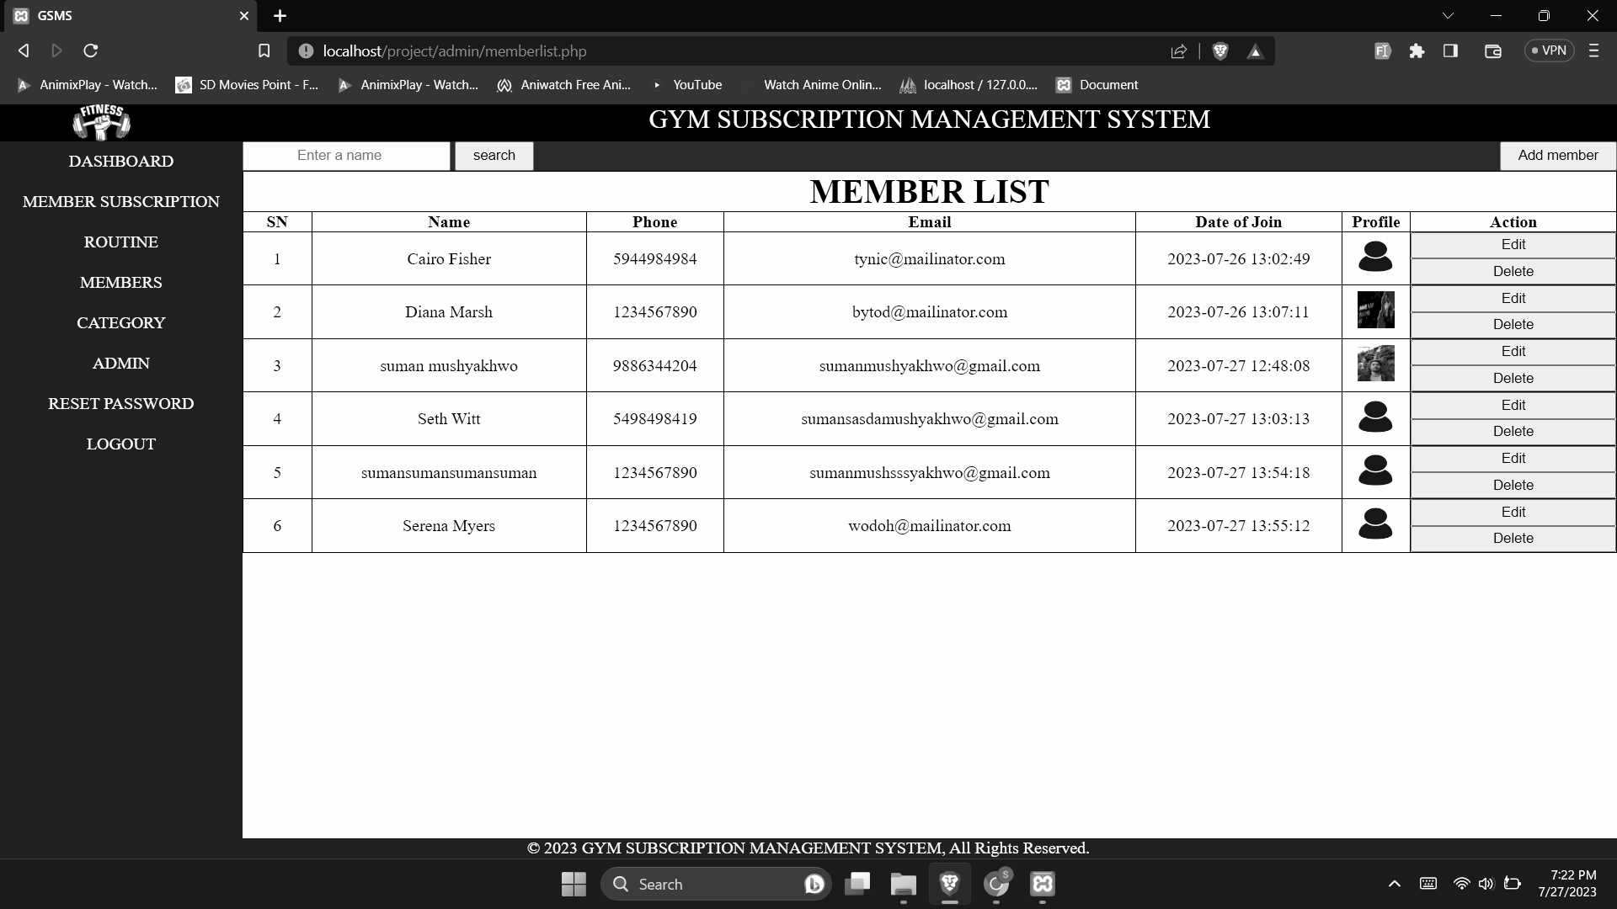

1. **Routine Management Page**



1. **Routine list**



1. **Category Management Page**



1. **Profile**

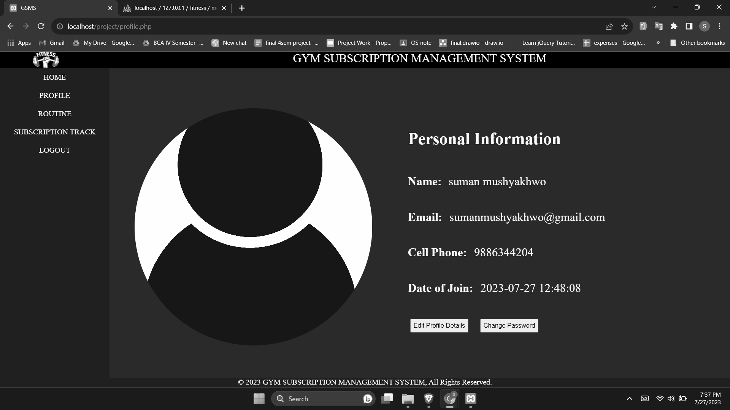

1. Subscription track

